Unit I • Scientific Method • Chapter 2
The Scientific Method

Everyone has a theory about why things happen. Most of those theories are never tested, and a great many of them turn out to be wrong. The scientific method is the procedure that decides which explanations survive contact with evidence. It is the whole difference between believing something and knowing it.
 |  | 
  Case Study
  The Twelve Sailors
  By May of 1747, HMS Salisbury had been at sea for about two months, patrolling the English Channel. Scurvy had taken hold below decks. Sailors’ gums swelled and darkened, their teeth loosened, and wounds that had healed years earlier split back open. Roughly thirty to forty of the ship’s three hundred and fifty men were sick. Nobody knew why. The leading explanations blamed bad air, damp quarters, laziness, or poor digestion.
  The ship’s surgeon was a thirty-year-old Scot named James Lind. Instead of arguing about which remedy was best, he decided to find out. On May 20 he chose twelve sick sailors whose cases looked as similar as he could find. He housed them all in the same part of the ship and fed them all the same basic diet. Then he split them into six pairs, and gave each pair one treatment: cider, drops of sulfuric acid, vinegar, seawater, a spiced paste with barley water, or two oranges and a lemon every day.
  Look closely at what he had just built. Twelve men who matched each other in nearly every way that could matter: same illness, same stage, same quarters, same food. Exactly one thing differed from pair to pair. That meant whatever happened next could be traced back to that one difference and nothing else.
  The citrus pair ran out of fruit after six days. By then one of the two men was back on duty and the other had almost fully recovered. Nothing else came close.
  Then the story turns frustrating. Lind did not conclude that citrus cures scurvy. He believed the disease came from the body decaying internally, and he suspected acid might slow that down. When he published his results in 1753, they sat in four unmarked pages buried inside a book of four hundred and fifty. The Royal Navy did not order lemon juice for its sailors until 1795, roughly fifty years later.
  James Lind, A Treatise of the Scurvy (1753). May 20 is now observed as International Clinical Trials Day.
  Key Question
  How do you get from noticing something to actually knowing it?
  Vocabulary
  - scientific method
  - observation
  - inference
  - hypothesis
  - independent variable
  - dependent variable
  - controls
  - experimental bias
  - experimental error
  - scientific law
  - scientific theory

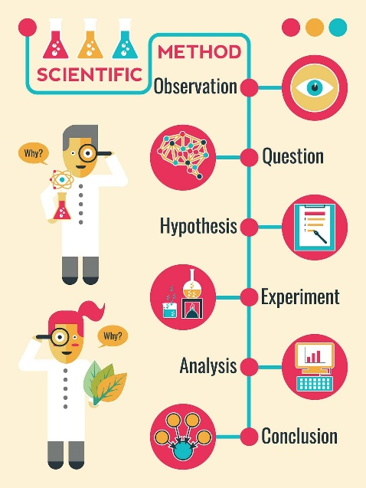
Every scientific investigation moves through the same stages, whether it happens at a school lab bench or in a hospital drug trial. Someone notices a problem, learns what is already known about it, forms an idea worth testing, builds a fair comparison, reads the results honestly, and draws a conclusion. That sequence has a name. The scientific method is a series of steps used to solve problems in scientific research, and it is the framework that keeps scientific claims honest, testable, and repeatable.
One warning before we start. These six steps are not a recipe that every scientist follows in strict order. Real investigations loop backward, stall, and restart. A researcher may reach step five, notice a problem, and go back to step three. What the steps give you is a shared structure and a shared vocabulary, so that a scientist in Haifa can read a study from Chicago and know exactly what was done.
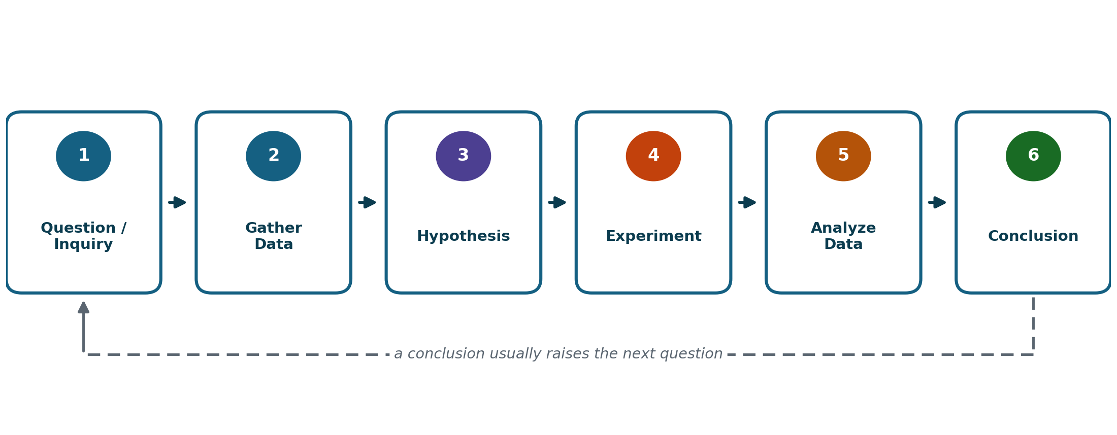
Figure 2.1 The six steps of the scientific method. Science rarely runs in a straight line, but these are the stages every investigation passes through.
Our Running Investigation
Why Does Some Bread Mold So Fast?
We are going to follow one question through all six steps, start to finish. Here is the situation. You buy a loaf of bread on Sunday. You leave half of it on the counter and put the other half in the refrigerator. By Thursday the counter half has green fuzz on it. The refrigerated half looks fine.
That is an ordinary annoyance. It is also a legitimate scientific problem. Watch for the phrase "Back to the bread" in each section ahead. That is where we pick the thread back up.

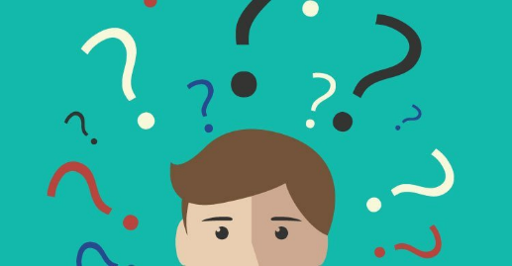
2.1 Step One: Question and Inquiry
Every investigation begins with somebody noticing something. That noticing is called an observation, information a scientist collects using the five senses or a measuring tool. Observations are the raw material of science. Hearing a rattle in a car engine, seeing a plant droop, and measuring a fever of 38.4 degrees are all observations.
Two things usually push an observation into an investigation. The first is plain curiosity, wanting to know for no other reason than that you want to know. The second is a problem that needs solving. A doctor who keeps seeing the same illness turn up in one neighborhood, or a farmer whose crop failed in a single field, has the second kind.
  By the Numbers
  The scale of scurvy
  Historians estimate that around two million sailors died of scurvy between 1500 and 1700. Vasco da Gama lost 116 of his 170 men on a single voyage.

What makes a question scientific
Not every question that occurs to you can be handled by science. A usable scientific question has four features.
- Answerable. You can reach the answer through direct observation or with a measuring tool.
- Testable. You can design an experiment or a set of measurements that would settle it.
- Built on what is already known. It starts from established knowledge rather than from nothing.
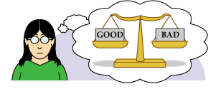
- Repeatable. Someone else asking the same question the same way should reach the same answer.
A rough shortcut, and it is only a shortcut: scientific questions tend to begin with what, and questions built on values or opinions tend to begin with why. "At what temperature does water boil?" can be answered by anyone with a thermometer. "Why is one restaurant better than another?" cannot, because better depends on personal taste and no measurement will settle the argument.
Question | Usable? | What makes the difference
At what temperature does water boil? | Yes | A thermometer answers it, and anyone can repeat the measurement.
Do people work better in the morning or the afternoon? | Yes | Vague as written, but it can be sharpened into a measurable comparison.
Is it wrong to take something that belongs to someone else? | No | This is a moral question. No instrument measures wrongness.
Do snakes travel in pairs? | Yes | Observation in the field settles it.
Should people be required to recycle? | No | Should is a question about values, not about what happens.
Do animals behave strangely before an earthquake? | Yes | Behavior can be recorded and compared to earthquake records.
Table 2.1 Sorting questions by whether science can reach them.
Back to the bread. The observation is simple: two halves of the same loaf, stored in two different places, ended up in very different condition. The question that follows is narrow enough to test. Does the temperature at which bread is stored affect how quickly mold grows on it? Notice that this asks what happens, it can be measured, and anyone with a loaf of bread could run it again.

▶ Reading Check
- Give one original example of an observation and explain what makes it an observation rather than an opinion.
- Rewrite this into a testable scientific question: "My phone battery seems worse in the winter."

2.2 Step Two: Gather Data  Once you have a good question, the temptation is to run straight to the experiment. Resist it. Before testing anything, scientists spend real time learning what is already known about the problem.
  Word Origin
  data
  From the Latin datum, meaning "something given." One measurement is a datum. Many measurements are data.

There are three main places to look. You can talk to people with real expertise in the area. You can go out and observe the situation directly and carefully, rather than relying on a vague memory of it. And you can read research that other scientists have already published, which is often the fastest way to learn what has already been ruled out.
Think about how a coach prepares for a game. A good coach does not invent plays the morning of the match. She watches film of the other team first, learns which side they favor and which player is slow turning left, and only then designs a plan built around what she found. The film does not win the game. It makes the plan worth running.
This step feels slow, and students almost always want to skip it. Skipping it is how people spend three weeks testing something that was disproved in 1964. Here is a real example. When a naval surgeon named James Lind set out in 1747 to find a treatment for scurvy, the disease killing his patients at sea, he started by learning what was already known. Citrus fruit had been suggested as a remedy on and off for a century, by sailors, by ship surgeons, and by at least one Spanish physician. What nobody had done was test it head to head against the alternatives. The research did not hand him the answer. It handed him the comparison worth running.
KEY IDEA Gathering background information is not the experiment. It is what makes the experiment worth running.

Back to the bread. A little research turns up several useful facts. Bread mold is a fungus, not a plant or a bacterium. Its spores are microscopic and drifting through the air in essentially every room you have ever been in, which means the bread does not need to be contaminated by anything unusual to grow mold. Fungi need moisture, warmth, and a food source to grow. And chemical reactions inside living things slow down as temperature drops. That last fact is the one that starts to look promising.

▶ Reading Check
- Name the three sources of background information described in this section.
- Explain what can go wrong when a researcher skips Step Two and jumps straight to the experiment.

2.3 Step Three: Hypothesis  Before we can build a hypothesis, we need one more distinction, and it is one students lose points on constantly.
  Word Origin
  hypothesis
  Greek hypo ("under") plus thesis ("a placing"). It is the foundation you place underneath an idea before you test whether it holds.
An observation is something you directly perceive or measure. An inference is a conclusion you reach by combining an observation with something you already knew. The observation is simply true. The inference is a step beyond the evidence, and it might be wrong.
Say you hear a low rumble outside. Hearing it is the observation. Deciding that a storm is coming is the inference. You did not hear a storm. You heard a sound, and you combined it with everything you know about thunder. The rumble might also have been a truck.
Observation (what you perceived) | Inference (what you concluded)
The classroom floor is wet near the door. | Someone came in with wet shoes.
My plant’s leaves are yellow. | It is not getting enough light.
The thermometer reads 38.9°C. | This person has an infection.
There are green spots on the bread. | The bread was left out too long.
Table 2.2 Every inference on the right could be wrong. Every observation on the left is simply what was there.

Now the term itself. A hypothesis is a plausible cause-and-effect explanation that can be tested by experimentation. It is really a specific kind of inference: a careful one, built on research rather than on a hunch, and written so that an experiment could show it to be wrong.  That last part matters. If there is no possible result that would count against your hypothesis, it is not a scientific hypothesis. A good one names a cause, names an effect, and is specific enough that two people would agree on whether the results supported it.
  Try This
  Thirty seconds
  Look out the nearest window. Write down one observation and one inference you could draw from it. Then ask a classmate whether they would have drawn the same inference.
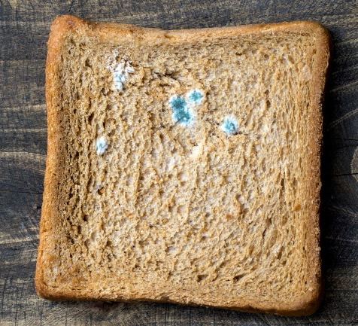
Hypotheses look the same across every branch of science. A student might propose that quiet instrumental music improves test scores compared to silence. An engineer might propose that adding weight to the wings of a paper airplane makes it fly straighter. A trainer might propose that colder weather reduces a football player’s sprint speed. In every case the pattern is identical. An observation leads to research, and research leads to a specific, testable explanation.
Back to the bread. Our observation was the difference between the two halves of the loaf. Our research told us that mold is a fungus and that cold slows biological activity down. Putting those together gives us a hypothesis worth testing: bread stored at colder temperatures will develop mold more slowly than bread stored at room temperature. It names a cause, it names an effect, and it is specific enough that our results could prove it wrong.

A Second Case From History
Semmelweis and the Doctors Who Would Not Wash
In the 1840s a Hungarian doctor named Ignaz Semmelweis worked at a Vienna hospital with two maternity wards. In one, staffed by medical students, roughly one mother in ten died of childbed fever. In the other, staffed by midwives, far fewer died. Same hospital, same city, same year.
Semmelweis noticed something the others had not. The medical students often came straight from performing autopsies. The midwives never handled corpses. From that observation he built an inference, and then a hypothesis: some invisible material from the autopsy room was traveling on the students’ hands and making the mothers sick. He required doctors to wash in a chlorine solution before examining patients. Deaths in his ward fell sharply within weeks.
His colleagues rejected the conclusion anyway. Germs had not been discovered yet, so his explanation had no known mechanism behind it, and the claim that doctors were killing their own patients was not one anyone wanted to hear. It took decades, and the later work of Louis Pasteur, before the idea was accepted. Being right is not the same as being believed.

▶ Reading Check
- Explain the difference between an observation and an inference in your own words, then give one original example of each.
- Explain why "something is wrong with my bread" is not a usable hypothesis, while "colder storage slows mold growth" is.
- Identify the observation, the inference, and the hypothesis in the Semmelweis case.

2.4 Step Four: Experimentation
An experiment is a fair test of a hypothesis. The word fair is doing a lot of work there, and most of this section is about what fairness actually requires.
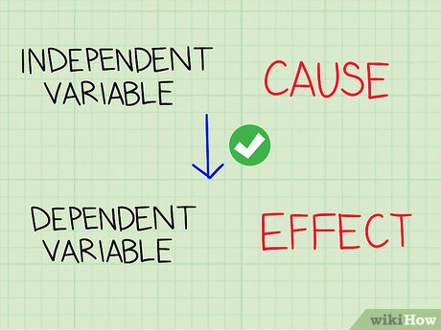
First, though, one thing worth saying plainly. An experiment that does not support your hypothesis is not a failed experiment. You have learned something real: that explanation can be crossed off. Ruling an idea out is genuine progress, and most working scientists spend far more time ruling things out than confirming them.
The two variables everyone mixes up
Every experiment is built around two variables. The independent variable is the factor you deliberately change. It is the possible cause you are testing. The dependent variable is the factor you measure to see whether it responded. It is the possible effect.
Here is the cleanest way to keep them straight, and it is worth memorizing:
KEY IDEA You change the independent variable. You measure the dependent variable. The dependent variable depends on what you did to the independent one.

If that still slips, use the sentence test. Fill in this blank out loud: "I am changing ____ to see what happens to ____." Whatever goes in the first blank is the independent variable. Whatever goes in the second is the dependent variable. The order in the sentence is the order of cause and effect.  The names themselves tell you the answer if you read them literally. Independent means it does not depend on anything else in the experiment; you set it yourself, before anything happens. Dependent means its value is at the mercy of the first one.
  Common Error
  Backwards variables
  Students often name the thing they care about most as the independent variable. Ask instead: which one did I physically set up, and which one did I have to wait and measure?
Controls, which means two different things
Testing one variable fairly means holding everything else still. The word controls covers two related ideas, and the fact that one word does two jobs is exactly why students get tangled up here.
  Watch Out
  One word, two jobs
  "Controlled variable" and "control group" are not the same thing. If a question says just "the control," read the sentence around it carefully.
- Controlled variables are the factors you deliberately keep constant so they cannot influence the result. In a plant experiment these would be pot size, soil type, and hours of sunlight.
- A control group is a baseline group that does not receive the independent variable, kept purely for comparison. Without one you have numbers but nothing to compare them against.
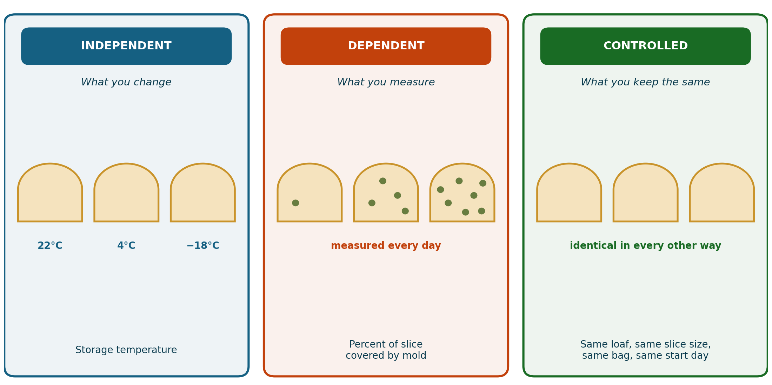
Figure 2.2 The three kinds of variables. One variable changes, one variable gets measured, and everything else is held still on purpose.
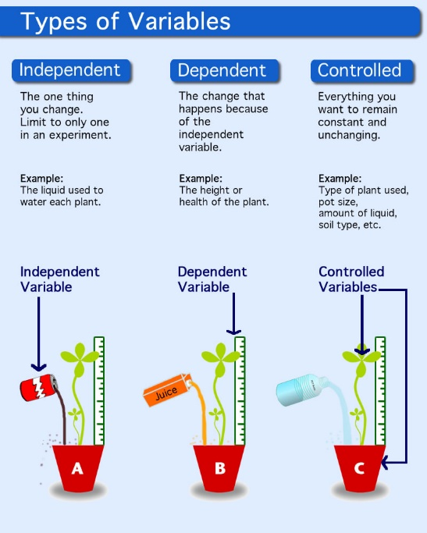
In 1747 that same naval surgeon, James Lind, tested six different scurvy remedies on twelve sick sailors aboard a ship at sea. The reason the experiment still gets taught almost three hundred years later is not the oranges that won. It is that he put all twelve men in the same quarters and fed them the same food. Those were his controlled variables, and they are what let him say the citrus was responsible rather than the bunk, the weather, or the rations.
Back to the bread. Here is the full design. The independent variable is storage temperature, tested at three levels: the kitchen counter at about 22 degrees Celsius, the refrigerator at about 4 degrees, and the freezer at about negative 18. The dependent variable is the percentage of each slice covered by visible mold. The controlled variables are everything else: all slices come from the same loaf, cut the same thickness, sealed in identical bags on the same day, and left untouched except when photographed. The counter slices are the control group, because leaving bread on the counter is the ordinary thing people already do.

▶ Reading Check
- In an experiment testing whether a new fertilizer increases tomato plant height, identify the independent variable and the dependent variable, then name two variables that should be controlled.
- Explain the difference between a controlled variable and a control group, using an example of your own.
Recording what happens
While the experiment runs, the data has to be captured as it happens rather than reconstructed from memory afterward. Depending on the situation that might mean taking precise measurements at fixed intervals, photographing or filming results so they can be reviewed later, or simply logging visible changes on a schedule. In our bread investigation it means photographing every slice at the same time each day and estimating the percentage covered.
Not every experiment looks the same
The bread investigation is a classic controlled experiment, but plenty of good science cannot be done that way. You cannot ethically assign one group of people to smoke for twenty years. Different questions call for different designs.
Design | How it works | Typical use
Survey | People are asked a set of questions and the answers are compared. | Psychology, public health, opinion research
Test subjects | Different individuals receive different treatments and are measured. | Medicine, drug trials
Cross-sectional study | Two or more groups are compared at the same point in time. | Comparing smokers and non-smokers today
Longitudinal study | One group is followed over a long stretch of time. | Tracking the same children into adulthood
Table 2.3 Four common experimental designs.
The last two are easy to confuse. A cross-sectional study takes a snapshot: it compares different groups all at once. A longitudinal study makes a movie: it follows the same group and watches it change. Snapshots are fast and cheap. Movies take years but reveal things a snapshot never could, like whether something that happened in childhood mattered thirty years later.

▶ Reading Check
- Would a study following the same fifty patients for fifteen years be cross-sectional or longitudinal? Explain how you know.
- Name one research question that could not be answered with a controlled experiment, and explain why not.


2.5 Step Five: Analyze Data
Collecting data is only half the work. Now you have to make sense of it, which means looking for patterns, comparing what you found against what you predicted, and being honest about anything that could have distorted the result. Two things distort results, and telling them apart is worth real attention.
Bias comes from the person
Experimental bias happens when a scientist’s expectations or personal beliefs affect how results are collected, interpreted, or reported. It is usually not dishonesty. It is usually not even conscious.
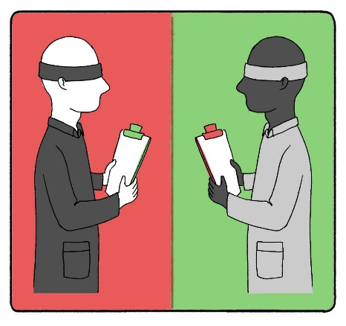
Picture a judge at a competition who happens to like one of the contestants. Even trying to be fair, that judge may round a borderline score upward. A researcher who is convinced a new medication works may read an ambiguous result as mild improvement. Nobody lied. The expectation quietly tilted the measurement.
Several safeguards push back against this. A large sample size makes it harder for a few unusual results to swing the overall pattern. Repetition and peer review, where other scientists independently check and rerun the work, catch mistakes and unconscious favoritism. And in medical research, studies are often run blind.
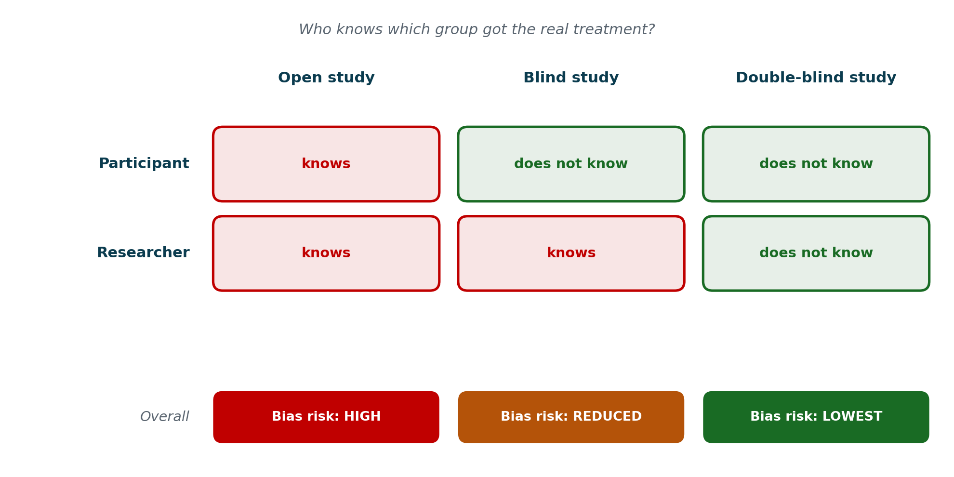
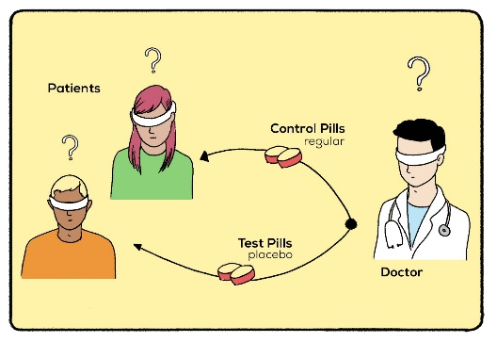
Figure 2.3 Blind and double-blind studies. In a blind study the participants do not know which group they are in. In a double-blind study, neither do the researchers taking the measurements.
In a blind study, participants do not know whether they are receiving the real treatment or a placebo, which is an inactive substance with no treatment effect at all. This matters because people who believe they are being treated often report feeling better even when they received nothing. A double-blind study goes further: the researchers handing out the treatment and recording the results do not know either. That closes the last door, because a researcher who does not know which group a patient is in cannot unconsciously score them more generously.
Error comes from the process
Experimental error, by contrast, refers to mistakes or unintended variations that happen during an experiment. These come from faulty tools, imprecise measurements, or ordinary human slips. If a thermometer was never calibrated and reads two degrees high, every single measurement in that experiment carries the same error, no matter how careful and unbiased the scientist was.
KEY IDEA Bias comes from the person running the experiment. Error comes from the process itself. One is a problem of expectations; the other is a problem of method.

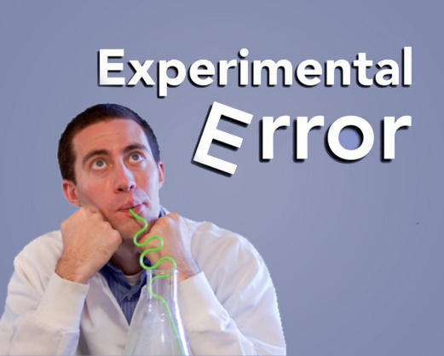
Back to the bread. Both risks are real here. Bias would look like this: you expect the freezer slice to stay clean, so when a faint gray patch appears on day twelve you decide it is probably flour and record a zero. Error would look like this: you cut the slices by hand, so the counter slice is noticeably thicker and holds more moisture than the others. The fix for the first is to have someone else score the photographs without knowing which slice is which. The fix for the second is a better knife and a ruler.

There is something worth naming here beyond technique. Guarding against your own bias means being willing to record a result you did not want. That is a habit of honesty, not just a lab procedure, and our tradition has a phrase for why it matters.
“חוֹתָמוֹ שֶׁל הַקָּדוֹשׁ בָּרוּךְ הוּא אֱמֶת • The seal of the Holy One is truth.”
— Shabbat 55a

▶ Reading Check
- A researcher is certain her fertilizer works, and while measuring plant height she rounds up whenever she is unsure. Is that bias or error? Explain.
- Explain why a double-blind study protects against bias more completely than a blind study.
- Give one example of experimental error that could occur in a school laboratory.

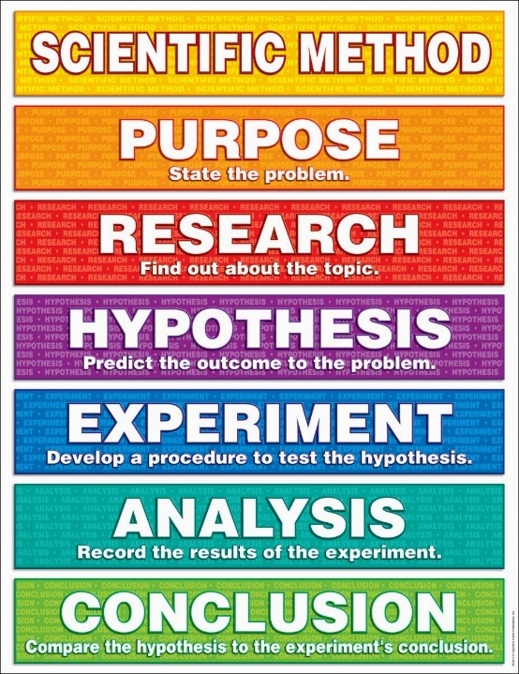
2.6 Step Six: Conclusion
The final step is to state plainly what the evidence showed, decide whether it supported the hypothesis, and consider what the findings mean beyond this one experiment. A strong conclusion usually opens a door rather than closing one. It answers the question you asked and hands you the next question.
Back to the bread. The data supports the hypothesis. Cold storage slowed mold growth substantially, and freezing prevented visible mold entirely across the fourteen days we watched. But look at how carefully that has to be worded. We did not show that freezing kills mold spores. We showed that no visible mold appeared in fourteen days. Those are different claims, and the second one is the only one our data supports.
That distinction leads straight to the next investigation. Is it the cold itself that slows the mold, or is it that refrigerator air is drier? Would a slice thawed after two weeks in the freezer mold immediately, which would tell us the spores were dormant rather than dead? Neither question existed before we ran the experiment.

The scurvy trial of 1747 shows how badly this step can go. James Lind ran an excellent experiment. He compared six treatments under identical conditions, and only the two sailors given oranges and a lemon recovered. Then he declined to draw the obvious conclusion. He could not explain why citrus would work, and he was still committed to his own idea that scurvy came from the body decaying internally. So he buried the result, hedged his recommendation, and the Royal Navy took about fifty years to act.  Vitamin C was not identified until 1932, nearly two hundred years later. Lind could not possibly have known the mechanism. But he did not need to know it in order to trust his own data, and that is the part he got wrong.
  Common Error
  Experiments do not prove
  Careful scientists write "the data support the hypothesis," not "this proves it." Proof belongs to mathematics. Science deals in evidence that is strong or weak.
KEY IDEA An experiment is only as useful as the conclusion someone is willing to draw from it.

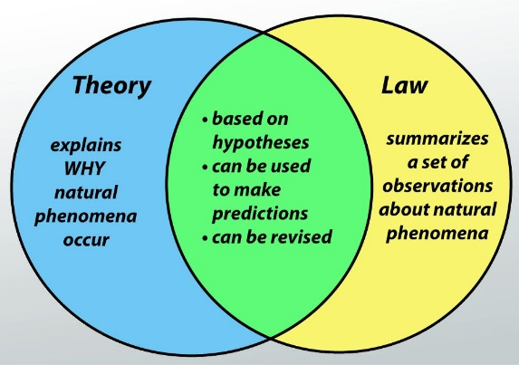
Laws and theories
When evidence piles up across many experiments and many researchers, scientific understanding can rise to the level of a law or a theory. These two words get confused constantly, including by adults who should know better.
A scientific law describes a pattern in nature that happens the same way every time. Newton’s Law of Gravity is the standard example. It describes precisely how objects with mass attract one another and lets you calculate exactly how fast a dropped ball will fall. What it does not do is explain why mass attracts mass at all.
A scientific theory is a thoroughly tested explanation for a set of observations, built from a large and consistent body of evidence. The Theory of Evolution does not merely state that species change over time. It explains the mechanisms, such as natural selection, that drive the change.
 | Scientific law | Scientific theory
Answers | What happens | Why it happens
Form | A description of a reliable pattern | An explanation supported by evidence
Example | Newton’s Law of Gravity | Einstein’s theory of general relativity
Can it change? | Yes, with credible new evidence | Yes, with credible new evidence
Outranks the other? | No | No
Table 2.4 Laws and theories do two different jobs. Neither is a stronger version of the other.
Gravity is the clearest illustration, because it has both. Newton’s law tells us how objects fall. Einstein’s theory of general relativity explains gravity as the bending of space and time. The law describes. The theory explains.
One misconception is worth correcting directly. In everyday speech, calling something "just a theory" makes it sound like a guess. In science the word means close to the opposite: a theory is among the most rigorously tested knowledge we have. A law is not more proven than a theory, and a theory is never promoted into a law. Both stay open to revision if credible new evidence appears, and that openness is exactly what keeps science honest.

▶ Reading Check
- Explain the difference between what a scientific law tells us and what a scientific theory tells us, using an original example of each.
- Correct this statement: "Evolution is only a theory, so it has not been proven like a law has."

The Six Steps, Start to Finish
- Question / Inquiry. Notice something and turn it into a testable question.
- Gather Data. Learn what is already known before touching an experiment.
- Hypothesis. Propose a specific, testable cause-and-effect explanation.
- Experiment. Test it fairly, changing one variable and holding the rest still.
- Analyze Data. Look for patterns, and account for bias and error.
- Conclusion. State what the evidence showed, and what to ask next.

Step | What happens | In our bread mold investigation
1. Question | An observation becomes a testable question. | Half a loaf molded on the counter; the refrigerated half did not. Does storage temperature affect mold growth?
2. Gather Data | Research what is already known. | Mold is a fungus, its spores are already in the air, and cold slows biological activity.
3. Hypothesis | Propose a testable cause and effect. | Colder storage will slow mold growth compared with room temperature.
4. Experiment | Change one variable, hold the rest constant. | Same loaf, same slices, same bags. Counter, fridge, freezer. Counter is the control group.
5. Analyze Data | Find the pattern, check for bias and error. | By day 14: counter 90 percent covered, fridge 9 percent, freezer zero.
6. Conclusion | State the finding and the next question. | Cold slowed mold growth. Is the cause temperature, or dryness?
Table 2.5 One question carried through all six steps.

Chapter 2 Review
The Scientific Method
A. Vocabulary Check
Write one complete sentence for each term that shows you understand what it means. Do not copy the definition out of the chapter.
- scientific method
- observation
- inference
- hypothesis
- independent variable
- dependent variable
- controls
- experimental bias
- experimental error
- scientific law
- scientific theory
B. Understanding Key Concepts
- A classmate says the scientific method is a fixed recipe that must always be followed in order. Explain what is accurate about that and what is misleading.
- Rewrite each of these into a testable scientific question: (a) the cafeteria food is bad, (b) my brother is a faster runner than me, (c) plants like music.
- Explain why Step Two comes before Step Four, and describe what can go wrong when a researcher skips it.
- Explain why a hypothesis counts as a type of inference rather than a type of observation.
- In an experiment testing whether daily screen time affects hours of sleep among teenagers, identify the independent variable, the dependent variable, and two variables that should be controlled.
- Explain both meanings of the word controls, and give an example of each from the bread mold investigation.
- In the 1747 scurvy trial, all twelve sailors were housed in the same quarters and fed the same basic diet. Explain why that detail mattered as much to the experiment as the six treatments did.
- Compare a cross-sectional study and a longitudinal study, and give a research question that would suit each one.
- Explain the difference between a scientific law and a scientific theory, then correct the claim that a theory becomes a law once it has been proven.
C. Analyzing Data
The graph below shows the results of the bread mold investigation described throughout this chapter. Use it to answer the questions that follow.
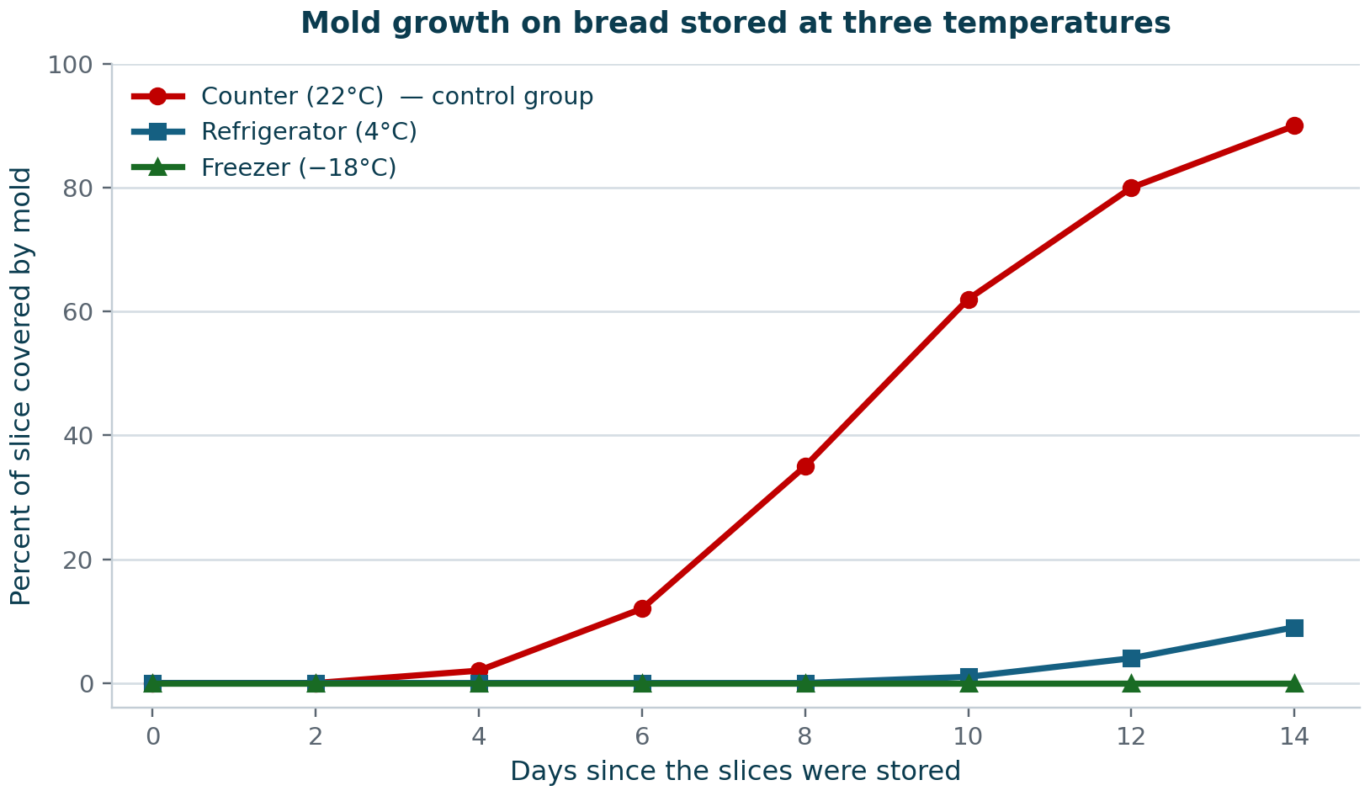
Figure 2.4 Results of the bread mold investigation. Percentage of each slice covered by visible mold, measured every two days.
- On roughly which day did mold first appear on the counter slice, and on roughly which day did it first appear on the refrigerated slice?
- Estimate what percentage of the counter slice was covered on day 10.
- The freezer line stays at zero for all fourteen days. Explain what conclusion this does support, and one conclusion it does not support.
- A friend wants to keep a loaf of bread usable for two full weeks. Which storage method would you recommend, and which specific data point supports your recommendation?
- Describe one thing you would learn by running this investigation for sixty days instead of fourteen.
D. Critical Thinking
Think Critically
- Lind produced clear results in 1747, yet the Royal Navy waited roughly fifty years to act on them. Using what you learned about conclusions, explain how a well-run experiment can still fail to change anything.
- A student running the bread investigation is convinced the freezer will win. On day 12 she notices a faint gray patch on the freezer slice and records it as "probably flour." Identify whether this is bias or error, and describe one change to the procedure that would have prevented it.
- Semmelweis was correct, and his colleagues rejected him partly because germs had not yet been discovered. Explain why a correct conclusion can be hard to accept when nobody can yet explain the mechanism behind it.
- Our investigation showed that cold slows mold growth, but not whether the cause is the low temperature itself or the drier air inside a refrigerator. Design a follow-up experiment that would separate those two possibilities. Name your independent variable, your dependent variable, and your control group.
E. Looking Ahead
You just did something in Part C that this chapter never actually taught you. You read a line graph, pulled specific values off it, compared three sets of results, and judged which conclusions the data could and could not support. Chapter 3 slows that down and takes it seriously. You will learn which kind of graph fits which kind of data, why the independent variable belongs on the horizontal axis and the dependent variable on the vertical one, and how a graph can be technically accurate and still mislead the person reading it.

